**PROJECT 2:**

PROJECT 2.1

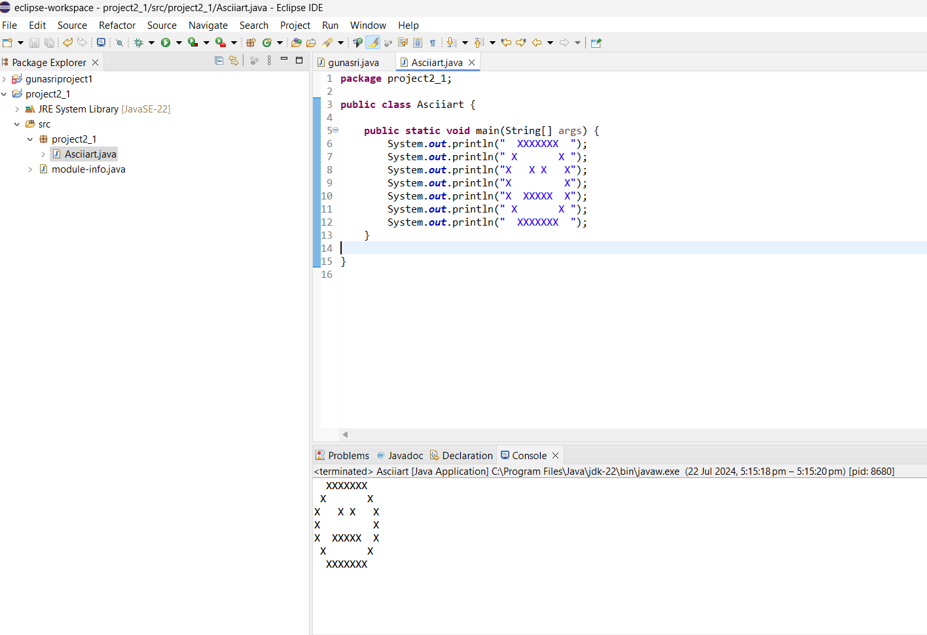

PROJECT 2.2:

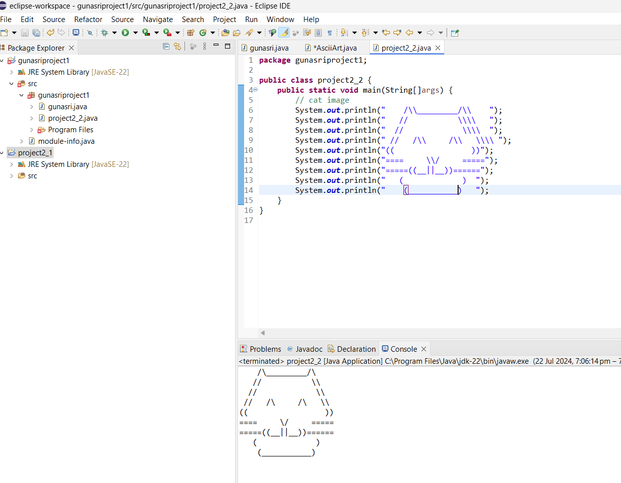

PROJECT 2.3

DOCUMENT TO CREATE SNAKE BOX FACTORY SOFTWARE DESIGN

**1. Object: SnakeBox**

**Properties:**

Dimensions: The size of the box, typically including length, width, and height.

MaterialQuality: The quality of the cardboard used to make the box.

SnakeType: The specific type of snake that will be placed inside the box.

**Behaviors:**

CalculateBoxVolume(): Computes the volume of the box based on its dimensions.

CheckMaterialQuality(): Assesses the quality of the cardboard to ensure it meets standards.

AssignSnakeType(SnakeType type): Assigns a specific snake type to the box and adjusts any related settings.

**2. Object: Snake**

**Properties:**

Species: The species of the snake.

Size: The size of the snake, which may influence the size of the box required.

HealthStatus: The current health status of the snake.

**Behaviors:**

ChangeHealthStatus(String status): Updates the health status of the snake.

Grow(Size newSize): Adjusts the size attribute of the snake as it grows.

GenerateReport(): Creates a report on the snake’s current health and characteristics.

**3. Object: Order**

**Properties:**

OrderID: A unique identifier for each order.

CustomerDetails: Information about the customer placing the order, such as name and address.

OrderStatus: The current status of the order (e.g., Processing, Shipped, Delivered).

**Behaviors:**

UpdateOrderStatus(String newStatus): Changes the status of the order to reflect its current state.

GenerateInvoice(): Creates an invoice based on the details of the order.

TrackShipment(): Provides tracking information for the shipment of the order.